## MINI PROJECT REPORT

**on**

**PLACEMENT RECRUITMENT SYSTEM**

**Submitted in partial fulfilment for the completion of**

**Mini Project I in**

**III Semester of B.E.**

**in**

**INFORMATION TECHNOLOGY**

**By**

**NIKHIL RANGA (160118737031)**

**PRANEETH KUMAR KADAMPALLY (16018737034)**

**Under the guidance of**

**Dr B.Veera Jyothi,**

**Assistant Professor,**

**Dept. of IT, CBIT.**

**DEPARTMENT OF INFORMATION TECHNOLOGY**

**CHAITANYA BHARATHI INSTITUTE OF TECHNOLOGY (A)**

**(Affiliated to Osmania University; Accredited by NBA(AICTE) and NAAC(UGC), ISO Certified 9001:2015)**

**GANDIPET, HYDERABAD – 500 075**

**Website:** [**www.cbit.ac.in**](http://www.cbit.ac.in)

**2019-2020**

**CHAITANYA BHARATHI INSTITUTE OF TECHNOLOGY (A)**

DEPARTMENT OF INFORMATION TECHNOLOGY

**(Affiliated to Osmania University)**

**GANDIPET, HYDERABAD – 500 075**

**CERTIFICATE**

This is to certify that the project work entitled “**PLACEMENT RECRUITMENT SYSTEM**” submitted to **CHAITANYA BHARATHI INSTITUTE OF TECHNOLOGY,** in partial fulfilment of the requirements for the completion of III semester of B.E. in Information Technology, during the academic year 2019-2020, is a record of original work done by **NIKHIL RANGA (160118737031)**, **PRANEETH KUMAR KADAMPALLY (160118737034)** during the period of study in Department of IT, CBIT, HYDERABAD, under my supervision and guidance.

**Project Guide**  **Head of the Department**

**Dr B.Veera Jyothi, Dr.Suresh Pabboju,**

Assistant Professor,Dept. of IT, Professor, Dept. of IT,

CBIT, Hyderabad. CBIT, Hyderabad.

**CONTENTS**

**Page. No.**

**ACKNOWLEDGEMENT** i

**DECLARATION** ii

**ABSTRACT** iii

**LIST OF FIGURES** iv

1. **INTRODUCTION**  1
   1. Motivation 1
   2. Basic Definitions 1
   3. Problem Statement 2
   4. Existing System 2
   5. Proposed System 2
2. **SOFTWARE & HARDWARE REQUIREMENTS** 4
3. **METHODOLOGY**

3.1 Architecture of Proposed System 5

1. **IMPLEMENTATION OF PROJECT** 6
2. **RESULTS AND SCREEN SHOTS** 8
3. **CONCLUSION & FUTURE SCOPE** 16

**BIBLIOGRAPHY** 17

**ACKNOWLEDGEMENT**

We would like to express our heartfelt gratitude to Dr **B.Veera Jyothi**, our project guide, for her invaluable guidance and constant support, along with her capable instruction and persistent encouragement.

We are grateful to our Head of Department, **Dr Suresh Pabboju**, for his steady support and the provision of every resource required for the completion of this project.

We would like to take this opportunity to thank our Principal, **Dr P.Ravinder Reddy**, as well as the management, for having designed an excellent learning atmosphere.

We thank to all members of the staff and our lab assistants for helping us to carry out the groundwork of this project. We also take this opportunity to thank our parents for their support to complete the project.

i

**DECLARATION**

We hereby declare that the work reported in the present report titled “**PLACEMENT RECRUITMENT SYSTEM**” is a record of work done by us in the Department of Information Technology, **Chaitanya Bharathi Institute of Technology, Hyderabad**.

No part of the report is copied from books / journals / internet and wherever the portion is taken, the same has been duly referred. The reported results are based on the project work done entirely by us and not copied from any other source.

Nikhil Ranga (160118737031)

Praneeth Kumar Kadampally (160118737034)

ii

**ABSTRACT**

**PLACEMENT RECRUITMENT SYSTEM**

The project named “Placement Recruitment System”, a student/company informationsystem is a computer based system. It maintains a large database of students wherein all theinformation of student is stored and company information including profile of company,eligibility criteria and facilities it provide etc. The software retrieves the data and displays as perthe user requirement.

The Placement Recruitment System is developed as an attempt to take a record ofcompany and students by restricting database to that of a particular class of students or company.The system provides the facility of viewing both the personal and academic information of thestudent and company. It can also search for eligible students. This software is easily accessibleand saves time. We developed this software using C++ programming language. Eligible studentsare recruited based on their performance.

**Technologies Used:**

Language: Object Oriented Programming Language-C++.

Platform: Dev C++, Notepad.

iii

**LIST OF FIGURES**

|  |  |  |
| --- | --- | --- |
| **Figures** | **Description** | **Page No.** |
| Figure 3.1 | Architecture of Proposed System | 5 |
| Figure 5.1 | Main page | 8 |
| Figure 5.2 | Student Signup Page | 9 |
| Figure 5.3 | Student Registration | 10 |
| Figure 5.4 | Aptitude Test | 11 |
| Figure 5.5 | Technical Test | 12 |
| Figure 5.6 | Admin Login | 13 |
| Figure 5.7 | Admin Homepage | 14 |
| Figure 5.8 | Student login page | 15 |

iv

**1.INTRODUCTION**

* 1. **Motivation**

The purpose of the project “PLACEMENT RECRUITMENT SYSTEM”, the manual work makes the process slow and other problems such as inconsistency and ambiguity on operations. In order to avoid this placement managed system is proposed, where the student information in the college with regard to placement is managed efficiently. It intends to help fast in fast access procedures in placement related activities and ensures to maintain the details of the student. Students logging should be able to upload their personal and educational information. The key feature of this project is that it is one time registration enabled.

The placement cell calls the companies to select their students for jobs via the campus interview. The placement cell allows the companies to view the student resumes in selective manner. They can filter the students profile as per their requirement. The job details of the placed students will be provided by the administrator. The administrator plays an important role in our project. Our project provides the facility of maintaining the details of the students and gets the requested list of candidates for the company who would like to recruit the students based on given query.

**1.2. Basic Definitions**

1.2.1. FILE HANDLING - In C++, files are mainly dealt by using three classes fstream, ifstream, ofstream available in fstreamheaderfile.  
**ofstream:** Stream class to write on files  
**ifstream:** Stream class to read from files  
**fstream:** Stream class to both read and write from/to files.

1.2.2. STANDARD TEMPLATE LIBRARIES -The C++ STL (Standard Template Library) is a powerful set of C++ templateclasses to provide general-purpose classes and functions with templates that implement many popular and commonly used algorithms and data structures like vectors, lists, queues, and stacks.

1

**Containers**

Containers are used to manage collections of objects of a certain kind. There are several different types of containers like deque, list, vector, map etc.

**Algorithms**

Algorithms act on containers. They provide the means by which you will perform initialization, sorting, searching, and transforming of the contents of containers.

**1.3. Problem Statement**

Students choose a specific college where the placement will be held, there is a need to maintain all these papers, causing large amount of space. It is manually done, chances of missing, difficult to handle the details of student.

**1.4. Existing System**

The existing system describes the features of the previous working model and their drawback. Existing system does all process manually. Placement officers register the information of students. If any modifications or updates are required in the profile of any student, it has to be done manually. This is tedious and time consuming, lack of security of data, took more man power, consumes large volume of paper and space. This process is so difficult when number of user’s increases.

The existing pen and paper based system does not give the assurance of confidentiality. Every user would want to keep their name confidential, which is not supported by the existing system. The project implemented overcomes all the above mentioned limitations. It has advantage over paper based systems as it is computerized.

**1.5. Proposed System**

The aim of the proposed system is to develop a system with improved facilities. The proposed system can overcome all the limitation of the existing system, such as student’s information is maintained in the database, it gives more security to data, ensures data accuracy, reduces paper work and save time, only eligible students get chance, it makes information flow efficient and paves way for easy report generation, reduce the space. proposed system is cost effective.

2

The purpose of the feasibility study is not to solve theproblem, but to determine the problem is worth solving.This helps to decide whether to proceed with the problem or

not. It involves the analysis of the problem & collection ofall relevant information relating to the product such asitems that would be input to the system, processing required

to carried those data, the output data required to beproduced by the system as well the various constraints onthe behavior of the system. "Placement Recruitment system” had undergone the feasibility study sothat the proposed system is possible for developmentdeployment in our college. The feasibility studyconcentrates on the following, such as OperationalFeasibility, Technical Feasibility, Economic Feasibility

3

**2. SOFTWARE& HARDWARE REQUIREMENTS**

The requirements specification is a technical specification of requirements for the software products. It is the first step in the requirements analysis process it lists the requirements of a software system including functional, performance and security requirements. The requirements also provide usage scenarios from a user, an operational and an administrative perspective. The purpose of software requirements specification is to provide a detailed overview of the software project, its parameters and goals. This describes the project target audience and its user interface, hardware and software requirements. It defines how the client, team and audience see the project and its functionality.

**Software Requirements :**

Operating systems: Windows* 7 or later, macOS, and Linux.

Development tools used: Dev C++/Code Blocks/Any other C++ compliers,

Notepad/Any other text file editor.

**Hardware Requirements :**

Processors: Intel Atom® processor or Intel® Core™ i3 processor.

32 – 64 bit processor

Hard Disk: (min)100 GB

Input device (mouse /keyboard) to select options

Sufficient RAM to run the program (Minimum 2GB)

4

**3. METHODOLOGY**

**3.1.Architecture of Proposed System**

Main Page

Display their Basic Details

Take up Exams

User

Selected

Select their Interested (eligiblie)company

Display whether selected or not

Technical

Aptitude

Result

Select Students Based on their credentials

Access Details of Students

Login to System

Login to System

Enter Basic Details

Sign up to System

**Figure 3.1**

5

**4. IMPLEMENTATION**

The success of the software system product is determined only when it is successfully implemented according to the requirements. The analysis and the design of the proposed system provide a perfect platform to implement the idea using the specified technology in the desired environment. The implementation of our system is made user friendly.

Any software project is designed in modules and the project is said to be successfully implemented when each of the module is executed individually to obtain the expected result and, when all the modules are integrated and run together without any errors.

This model has been implemented using object oriented concepts that mainly uses files to store data that has been manipulated and implemented in the process of execution. The project made use of the following files:

1. student.txt : It contains the login ID’s and passwords of all the students who have registered.
2. studentdata.txt : It contains the student details and their marks which they have scored in the company’s test.
3. admin.txt : It contains the login ID’s and passwords of all the companies.
4. google.txt : It contains the details of the students who applied for the google company and the name of the student who is selected.
5. amazon.txt : It contains the details of the students who applied for the amazon company and the name of the student who is selected.
6. deliote.txt : It contains the details of the students who applied for the delloite company and the name of the student who is selected.
7. jpmc.txt : It contains the details of the students who applied for the jpmc company and the name of the student who is selected.
8. microsoft.txt : It contains the details of the students who applied for the microsoft company and the name of the student who is selected.
9. gs.txt : It contains the details of student selected for google company.
10. as.txt : It contains the details of student selected for amazon company.
11. ds.txt : It contains the details of student selected for deliote company.
12. ms.txt : It contains the details of student selected for microsoft company.
13. js.txt : It contains the details of student selected for jpmc company.

6

The student who logged in for the first time has to create a new username and password these will be stored in the student.txt. After that student has to enter his/her details and has to select a company according to GPA and write the company’s aptitude test and if the student gets enough marks the student can enter technical test. After completing all the tests the details are submitted to the corresponding company and these details are stored in studentdata.txt also in the form of a record (Object).

The admin can log in into the main admin portal after entering the correct ID and password, after which he/she can have access to see the details of the students who applied and written the tests of their company. And the name of the student who is selected for the company is displayed. The selection is done by the marks of the students.

After then when a student who already registered logs in,the basic details and the status whether he/she is selected for the company is displayed

7

**5. RESULTS AND SCREENSHOTS**

**Main page :**

**A screenshot of a computer

Description generated with very high confidence**

**Figure 5.1**

The Placement Recruitment Systems’ main portal has two logins : Admin and Student. The admin has to login with a unique ID and password which he only knows. Whereas the student first has to register if he/she newly logged in, otherwise he has to sign up.

8

**Student Signup Page :**

**A close up of a logo

Description generated with very high confidence**

**Figure 5.2**

The student can register with a unique login ID and a password. Each student will be having their unique ID.

9

**Student Registration :**

**A screenshot of a cell phone

Description generated with very high confidence**

**Figure 5.3**

After creating ID, the student has to enter his/her details and select a company from the companies list shown.

10

**Aptitude Test :**

**A screenshot of a cell phone

Description generated with high confidence**

**Figure 5.4**

After selecting a company the student has to write the corresponding company’s aptitude test.

11

**Technical Test :**

**A screenshot of a cell phone

Description generated with very high confidence**

**Figure 5.5**

After completing the aptitude round, if the student scores enough marks to write the technical round he/she will be taken to the technical test. After completion of the technical round the details of the tests are sent to the respective companies.

12

**Admin login page:**

**A close up of a logo

Description generated with very high confidence**

**Figure 5.6**

When the admin has logged into the admin portal with his/her unique ID and Password which is predefined.

13

**Admin Homepage :**

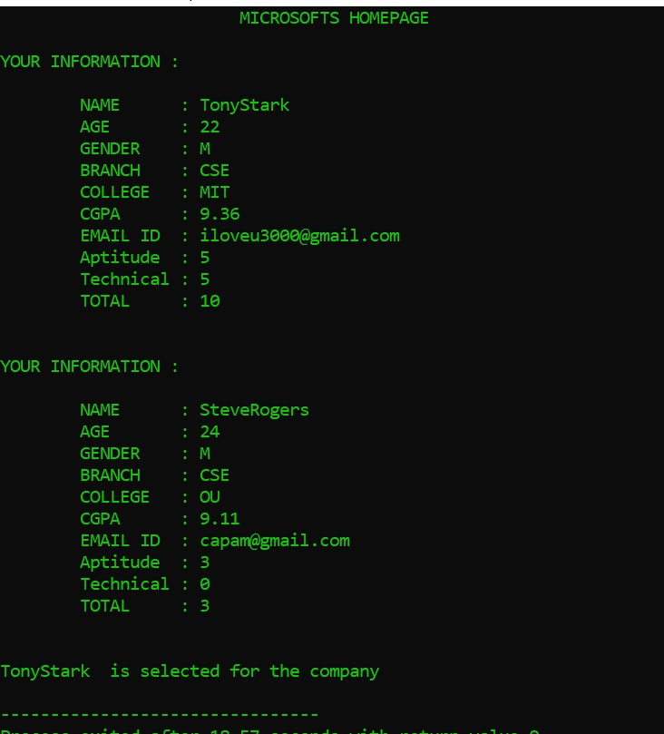

**Figure 5.7**

Admin can have access to see the details of the students who applied for their company, and also the name of the student who got selected for the company.

14

**Student login page :**

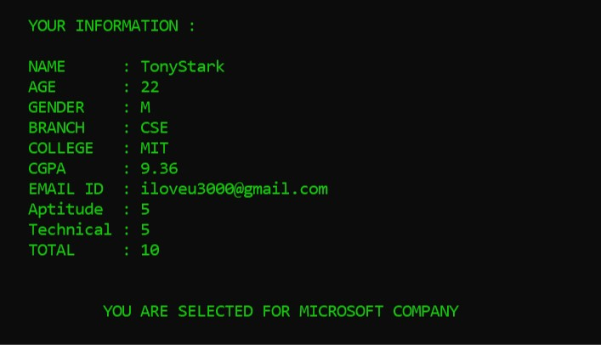

**Figure 5.8**

After that when a student logs into his/her login using their ID and password. The corresponding students are displayed and also the status whether the student has got selected for the applied company.

15

**6**. **CONCLUSION AND FUTURE SCOPE**

As mentioned elsewhere in this report, The introduction, problem definition of the project has been completed successfully to college Placement Recruitment system by maintaining the student details related to placement in an efficient manner. We would like to conclude that the project has achieved what it set out to accomplish, even though there will always be areas for potential improvement and enhancement.

As stated above, there is considerable scope for improvement, and many changes can be made to enhance this project. These include a smoother user interface. The same problem statement can be implemented using front end web development languages like HTML 5 , CSS 3,and JAVASCRIPT etc. A website having all the above features can make it easy to access for the users. Website also has the advantage of storing large data if the count of the users is high. Similarly an android app can also be developed for the problem statement mentioned. Android app has its own advantages. By this we can conclude that the future scope of this project is very high when implemented using advanced technologies.

16

**BIBILIOGRAPHY**

Text References:

1. Mastering C++ by K R Venugopal, T Ravishankar.

2. The Complete Reference C++, Fourth Edition by Herbert Schildt.

Web Resources:

1. [www.nptel.co.in](http://www.nptel.co.in) : It has been used for learning basics of object oriented concepts.
2. [www.tutorialspoint.com](http://www.tutorialspoint.com) : It is used to get all definitions for the project related data.
3. [www.wikipedia.com](http://www.wikipedia.com) : It is used to get more information about STL’s in C++.
4. [www.quora.com](http://www.quora.com) : It is used to get the queries answered if any.
5. [www.geeksforgeeks.com](http://www.geeksforgeeks.com) : Used to understand and implement few code snippets.

17